**X370 Term Project Report – Beginner Investor**

Authors: Yan Lin, Hanke Xiao, Ethan Wang, Zhenyu Yan

Date:  5/01/2018

**Introduction**

Our project provides tools that enable beginners to learn about the stock market. Large real-time dataset is retrieved from IEX API and stored in local database. We use innovated way to query the database, generate meaningful results and perform the data analysis for stock basics tutorials. Through using the tools, users can gain a fundamental knowledge of a single stock and/or the overall stock market. We attach straightforward interpretations to each stock attribute/metrics, such as ROA, P/E Ratio, Market Cap and etc.

**Original Contributions**

Unlike the existing finance websites which often only provide comprehensive stock data that an experienced investor is interested in, we help beginners to develop a basic understanding of stock market in a quick and convenient way. We not only query the database to find price trend and status, but also give users insights on which stock has the least/most return and risk in the entire market based on the stock metrics and industries interested. Moreover, we offer on-site valuation analysis and metrics interpretation for stocks searched and compared, so that the data displayed make sense to beginner investors. We not only display the data but more importantly derive useful information out of it. This database usage can also serve to identify new investment options.

**Social Impact**

Two-thirds of Americans cannot pass a basic financial literacy test (Farber, 2016). Our website will help to remedy these problems by taking difficult investment questions and providing a simple, structured way to understand stock market. With this educational website, people with no investment background can search for stock information, and meanwhile, obtain a quick understanding of stock valuation. The user interface is designed to be colorful and fun, so it can foster an interest in learning. Having the basic knowledge of investment, people are more likely to start doing more research and actually making investment. Eventually, appropriate investment can help people better manage their wealth and make lives better.

**System Architecture**

* *Structure:* A database and web-based system that interacts with stock data
* *Functions*:
  1. Provide processed info about a stock (data taken from IEX Trading API)
  2. Display basic stock metrics with onsite interpretation
  3. 15 days stock’ prices trend graphs

1. Compare two stocks
   1. Display basic stock metrics with onsite interpretation
   2. 15 days stocks’ prices trend graphs
   3. Stock comparison analysis – algorithm derived from research (refer to Investopedia articles)
2. Rank stocks in market based on industries and return-and-risk valuation metrics
   1. High return – highest PE ratio, highest EPS, highest Dividend
   2. Low Risk – least price change, smallest Beta, largest market cap

* *Features*: simple UI allows for even users with little to no financial background to understand stock market

**Some screenshots of pages** – for all screenshots of pages refer to folder “screenshots”

Homepage:

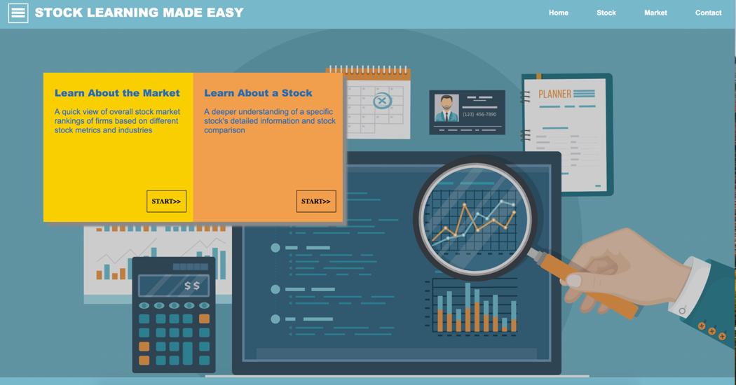

Stock Search Page with a Price Trend Graph:

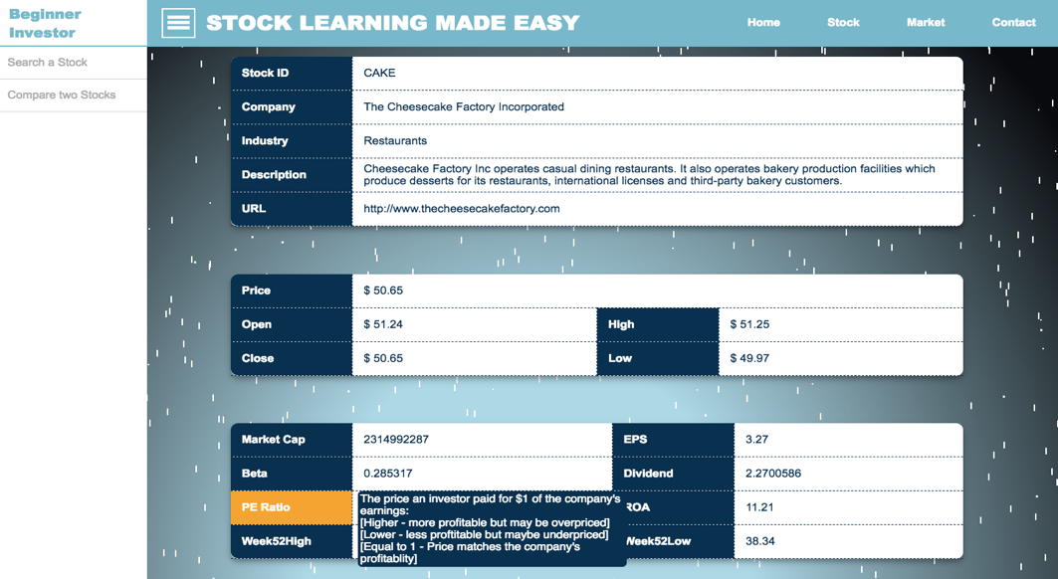

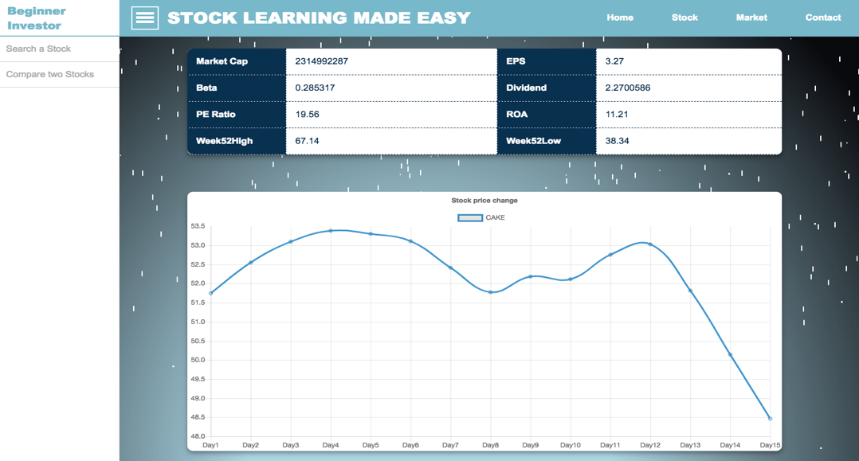

Stock Comparison Page with a Price Trend Graph:

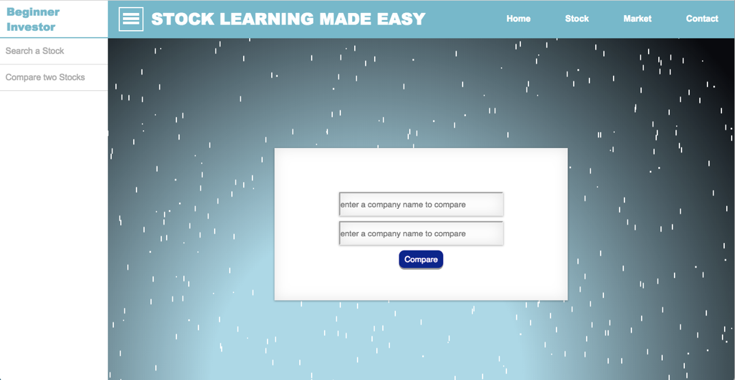

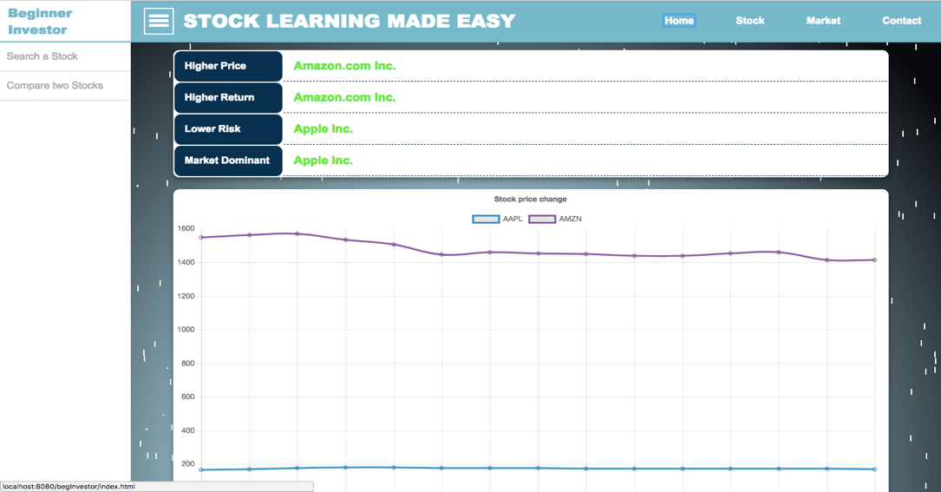

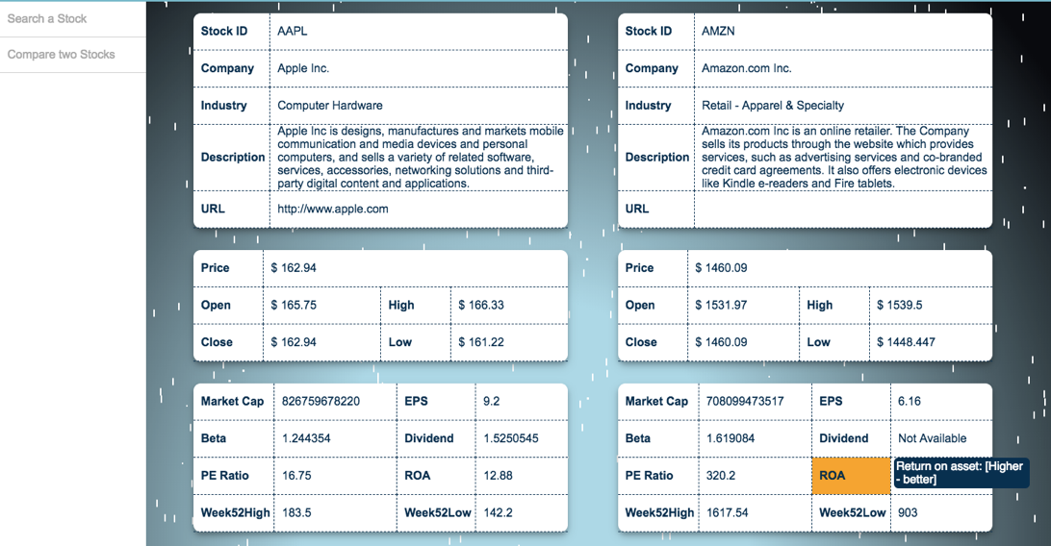

Market:

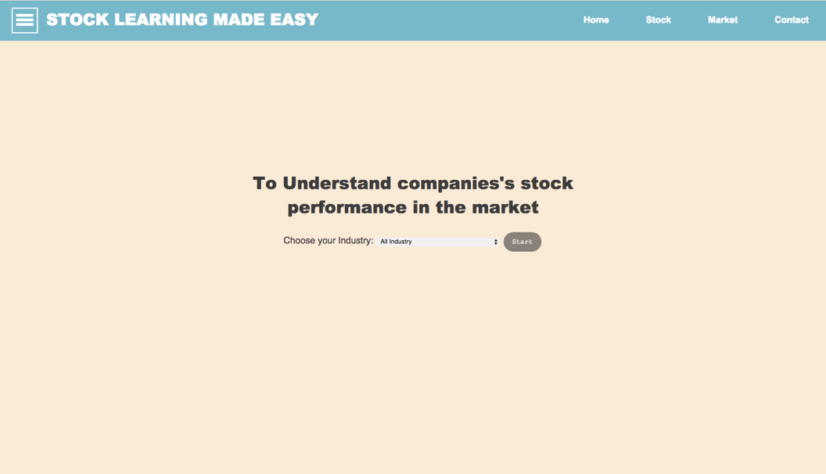

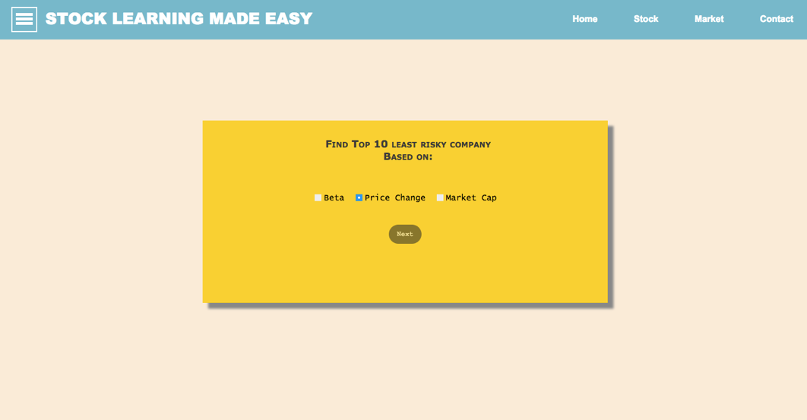

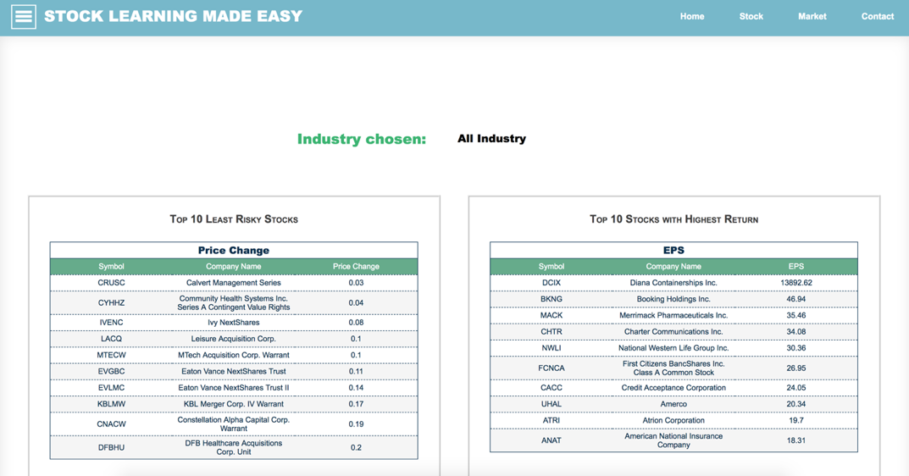

**Technical Details**

* Database Backend:
  + Data Source: stock data taken from IEX Trading API and stored locally as historical data for later usage. A separate java file is written to update current data of prices. un separately.
  + MySQL: used as a database backend
  + Maven: Maven project to collect our data from IEX Trading API
* Web Application:
  + HTML: content of web pages
  + CSS: layout of web pages
  + JavaScript: behavior of web pages
  + JQuery: front end
* Major supports:
  + AJAX: get data and display on webpage without refreshing page
  + JDBC: connectivity
  + Java: backend

**Related Work**

* Investors Exchanges (IEX) also provides stock and market information to users through displaying the data of pricing and valuation metrics data; however, there is no explanation or further analysis for users to better understand what the data means.
* Investopedia offers explanations and articles on various financial terms. It teaches people what different stock metrics are and how to use them to evaluate investments. Nonetheless, it is not connected to real stock data.

**Team Member and Responsibilities**

|  |  |
| --- | --- |
| **Team Member Name** | **Responsibility** |
| Hanke Xiao | Manage the team, frontend, backend, and query. |
| Yan Lin | Frontend and query |
| Ethan Wang | Data fetching from IEX Trading API |
| Zhenyu Yan | Frontend |

**Conclusion**

We believe our website will bring great benefits to users: it reduces user’s time cost that are used to search and compare different stocks before; it provides users with analyzed and calculated data that are essential to make decision; it helps those who are new to the stock market trade by providing critical matrix with interpretation. We also believe this easy-to-use website will benefit the society as a whole because all the benefits mentioned above enable people to manage their financial portfolio and assets wisely.

**References**

Farber, M. (2016, July 12). Nearly Two-Thirds of Americans Can't Pass a Basic Test of Financial Literacy. Retrieved March 22, 2018, from <http://fortune.com/2016/07/12/financial-literacy/>

Nickolas, Steven. “What Is the Difference between Earnings per Share and Dividends per Share?” *Investopedia*, Investopedia, 7 Feb. 2018, [www.investopedia.com/ask/answers/032515/what-difference-between-earnings-share-and-dividends-share.asp](http://www.investopedia.com/ask/answers/032515/what-difference-between-earnings-share-and-dividends-share.asp).

Picardo, CFA Elvis. “Comparing The P/E, EPS And Earnings Yield.” *Investopedia*, Investopedia, 6 Apr. 2018, www.investopedia.com/articles/investing/120513/comparing-pe-eps-and-earnings-yield.asp.

Fingas, Jon. “New Stock Exchange Fights Unfair Online Trading.” *Engadget*, 22 Aug. 2016, www.engadget.com/2016/08/21/iex-stock-exchange-fights-high-frequency-trading/.